[DCO-2461] Motive Authenticated - Functional Accessibility issue in security question Created: 01/May/24 Updated: 06/May/24
Status: | In External Review
Project: | Journey Manager
Components: | None
Affects versions: | None
Fix versions: | Accessibility

Type: | Story | Priority: | None
Reporter: | Sanya Khandhuja | Assignee: | Fusi Olateru
Resolution: | Unresolved | Votes: | 0
Labels: | Motive, MotiveAuthenticated
Remaining Estimate: | Not Specified
Time Spent: | Not Specified
Original estimate: | Not Specified

Attachments: | image-20240501-141100.png
QA Bug Count: | 0
Days Open: | 5 days
Bug Count: | 0
Hours Variance: | 0
Hours Remaining: | 0
Hours Target PMO: | 0
Sprint:
Days Open: | 5

Description

Functional accessibility issue: The security question input field contains placeholder text that lacks sufficient contrast. The contrast between the foreground and background text colors is insufficient (2.3:1), falling short of the 4.5:1 required for regular text.
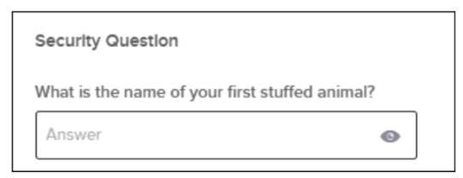
■ Recommendation: Change all problematic foreground/background pairings to higher contrast ratios that meet or exceed the required minimum.

Comments

Comment by Fusi Olateru [ 03/May/24 ]
okta
Generated at Mon May 06 21:50:51 UTC 2024 by Ian Hicks using Jira 1001.0.0-SNAPSHOT#100252-rev:aa264b414382dcd2bbea0c3e63c78e358e7de0d5.

